Introduction:-

The project name “College Management System” is basically about how to manage an educational institute online. This system helps to improve the efficiency level of an educational institute, through this system the administration of an educational institution can easily manage the whole process of online, with the help of this system the administration can maintain the information related to,
- Student Records.
- Teacher Records.
- Course Records.
- Assignments Records.
- Attendance Records.
- User’s Records.
- Class Records.

CMS basically depends on three major types of consoles,
- Admin Console.
- Student Console.
- Teacher Console.

Objectives:-
System” is to create and run a paper less educational institution. The practical application of this system will automatically reduce the cost if an educational institution. The reduction of cost is in the sense of,
- Paper cost.
- Employee salaries.
- Transport Expense.
- Power Tariff Expense.
- Inventory Cost.

The second main objective of “College Management System” is to create a virtual educational institute, through this concept the physical appearance of both the teacher and student is not required.
Project Overview:-
Basically this system consists of three major consoles,
- Admin Console.
- Student Console.
- Teacher Console.

- Admin Console:-
In the admin console we have 9 different fields,
- Classes.
- Teachers.
- Lectures.
- Users.
- Add class.
- Add Course.
- Add User.
- Reports.
- Logout.

- Classes:-
In this field we can see the no. of classes added in our database, alone with the name and session of the class. By selecting a particular class we can also see the no. of students added in the class. We can also delete a particular class by simply pressing the button of delete.

- Teachers:-
In this field we can see the no. of teachers added in our database. We can also delete the record of a particular teacher.
- Lectures:-
In this field we can see the record of the overall lectures, alone with the ID of the class and the name of the course. By a simple click we can also see the detail of a particular lecture which includes lecture ID, class ID, Teacher name, Type of lecture, starting and ending dates, starting time and room no. We can also delete the record of a lecture.

- Users:-
In this field we can see the total no. Of the users, type of the users, and ID of the users. We can also delete the record of a particular user.

- Add class:-
By clicking on this field a new window will appears, with the help of that window we can add a new class by putting the information regarding to class ID, session, semester and no. of subjects thought in that class.

- Add course:-
By clicking on this field a new window will appears, with the help of that window we can add a new course by putting the information regarding to class ID, teacher, course name, type, starting and ending date, starting time, room no. , duration and description of the course.

- Add user:-
By clicking on this field a new window will appears, with the help of that window we can add a new user by providing the information regarding to user ID, password, user type.

- Reports:-
By clicking on this field a new window will appears, with the help of that window we can see the reports of the students, classes, courses, assignments, attendance and teachers.

- Logout:-
By clicking on this field you can logout from the admin console.

- Student Console:-
In the student console we have 4 different fields,
- Courses.
- About.
- Help.
- Logout.

- Courses:-
In this field we the see the list of the courses and their detail.

b) About:-
In the field we can see the information regarding to the organization.

C) Help:-
In the field we can see the information regarding to the user help and contacts of the organization.

D) Logout:-
By clicking on this field you can logout from the student console.

- Teacher Console:-
In the teacher console we have 4 different fields,
  - Courses.
  - About.
  - Help.
  - Logout.

- Courses:-
In this field we the see the list of the courses and their detail.

b) About:-
In the field we can see the information regarding to the organization.

C) Help:-
In the field we can see the information regarding to the user help and contacts of the organization.

D) Logout:-
By clicking on this field you can logout from the teacher console.

GANT Chart:-

 | Starting Date | Ending Date | Duration  (Working Days)
Project Classes | 01-10-10 | 12-10-10 | 6 Days
Data Flow Diagram(DFD) | 15-10-10 | 17-10-10 | 3 Days
Entity Relationship Diagram(ERD) | 22-10-10 | 01-10-10 | 6 Days
Database Tables | 06-11-10 | 08-11-10 | 3 Days
Web pages | 13-11-10 | 15-11-10 | 3 Days
Designing | 20-11-10 | 29-11-10 | 6 Days
Compiling | 03-12-10 | 05-12-10 | 3 Days

Requirement Analysis:-
1) Software’s:-
- Macromedia Dreamweaver MX 2004
- Wamp server 2
- Adobe Photoshop 7
- Apache 2.2
- Php 5.2
- Mysql 5

  - Hardware:-
- 320 GB Hard drive.
- 3 GB Ram.
- Laptop

Application Design:-

1) Data Flow Diagram (DFD):-
Admin
Request For
Verification
Not
Approved
Login System
Registration
Approved
Admin Page
Add Course
Add class
Add
User

b) Student (DFD):-
Student
Request For
Verification
Not
Approved
Login System
Registration
Approved
Student Page
View Course
View
Assignment
Submit
Assignment

C) Teacher (DFD):-
View Course
View
Submission
Teacher
Request For
Verification
Not
Approved
Login System
Registration
Approved
Teacher Page
Assign
Assignment
Mark
Attendance

2) Entity Relationship Diagram (ERD):-

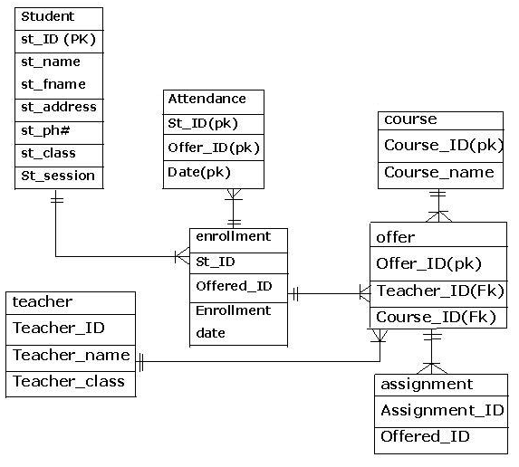

Database Tables:-
1) Main table:

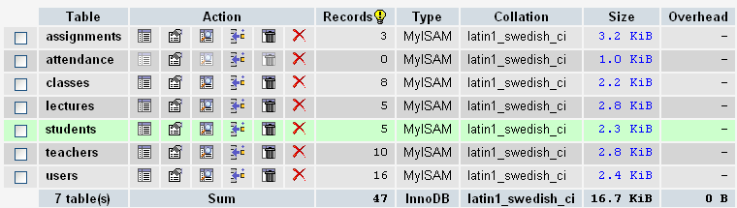

2) Assignment Table:-
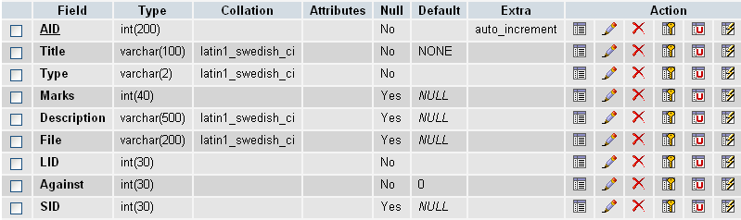

3) Attendance Table:-
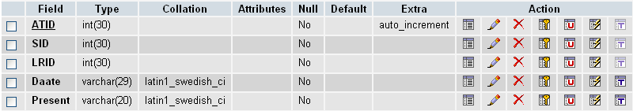

4) Class Table:-
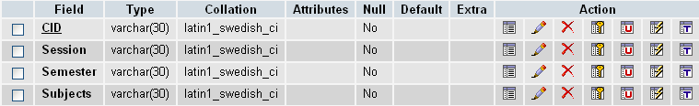

5) Lectures Table:-
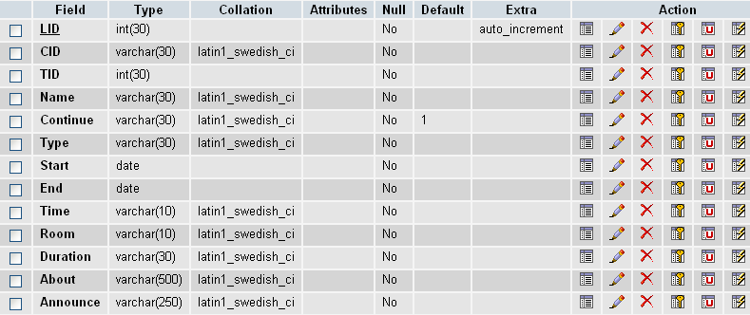

6) Student Table:-
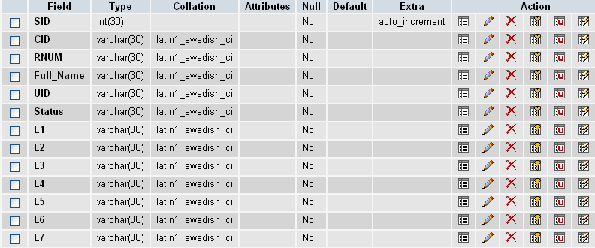

7) Teacher Table:-
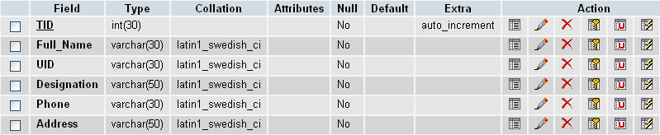

8) User Table:-
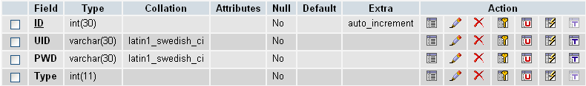

System Reports:-
1) Student Report:
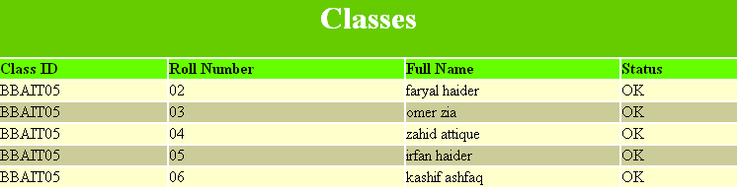

2) Teacher Report:-
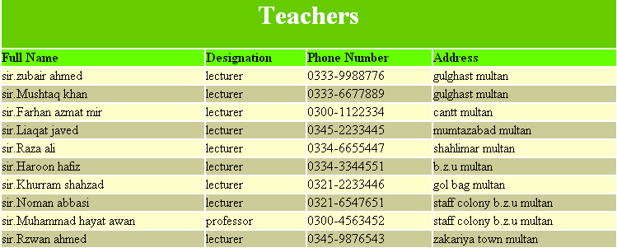
3) Class Report:-
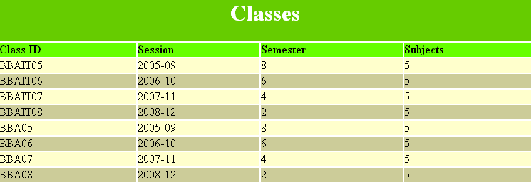

4) Assignment Report:-
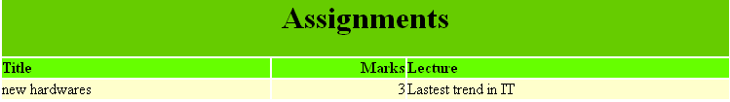

5) Course Report:-
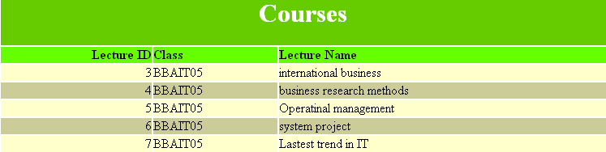

User Manual:-
1) Login page:-
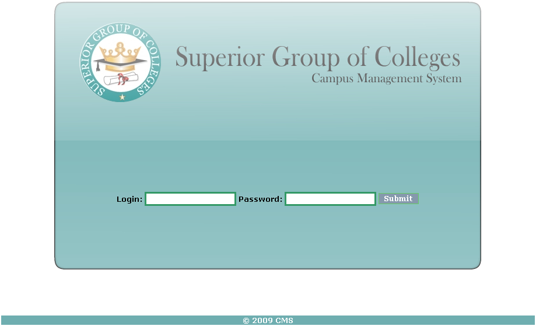

2) Admin Main page:-
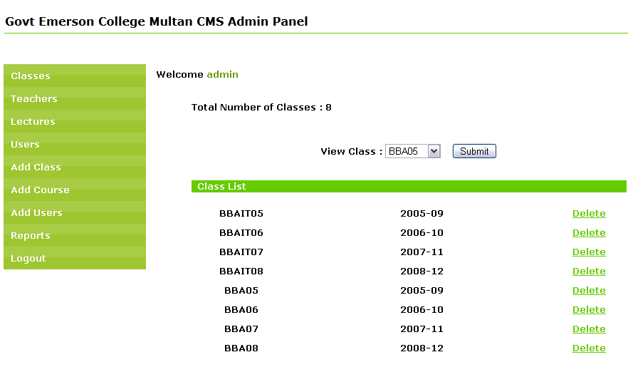

a) Classes page:-
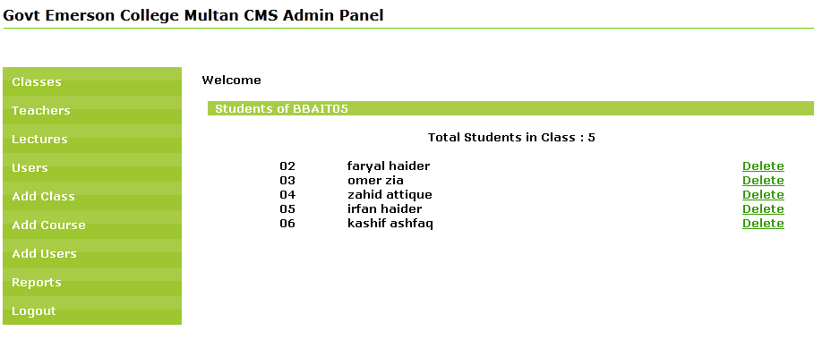

b) Teachers page:-

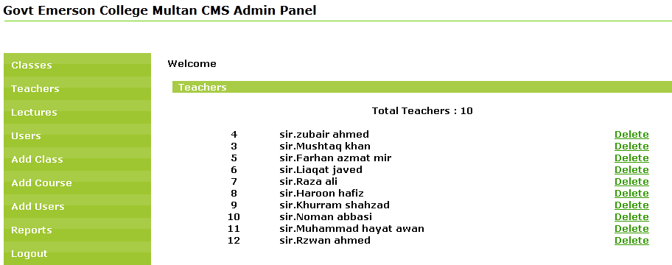

c) Lectures page:-
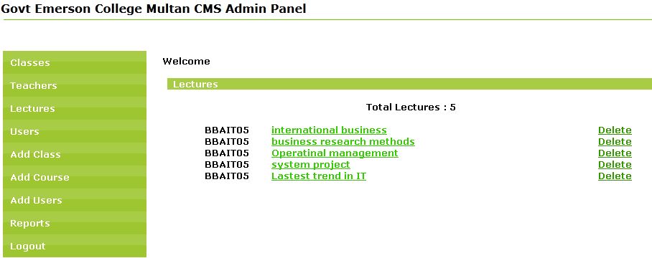

d) Users page:-
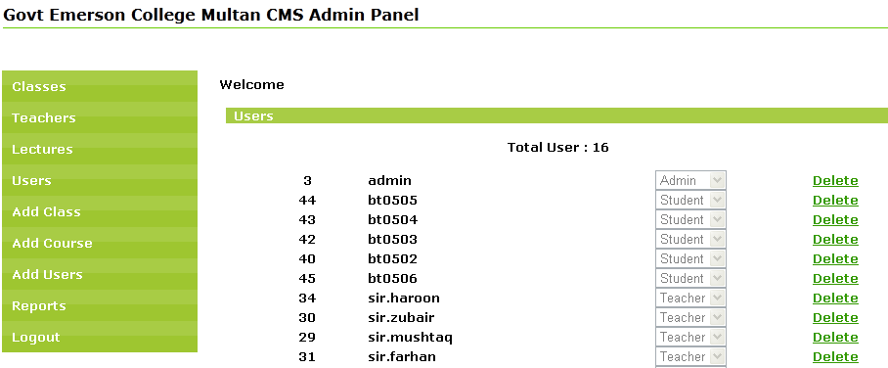

e) Add Class page:-
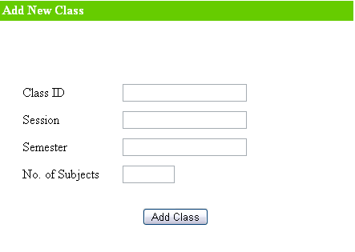

f) Add Course page:-
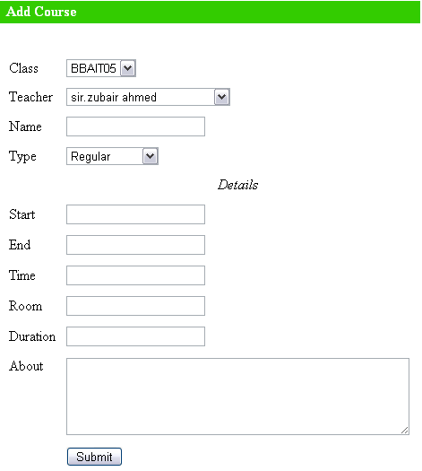

g) Add user page:-
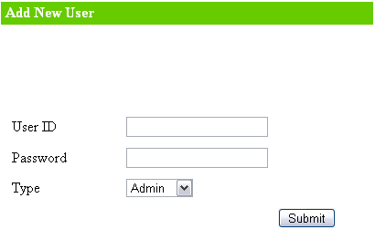

h) Reports page:-
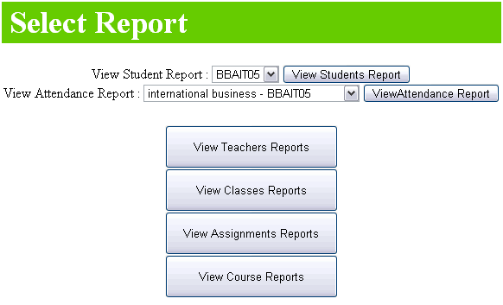

3) Student main page:-

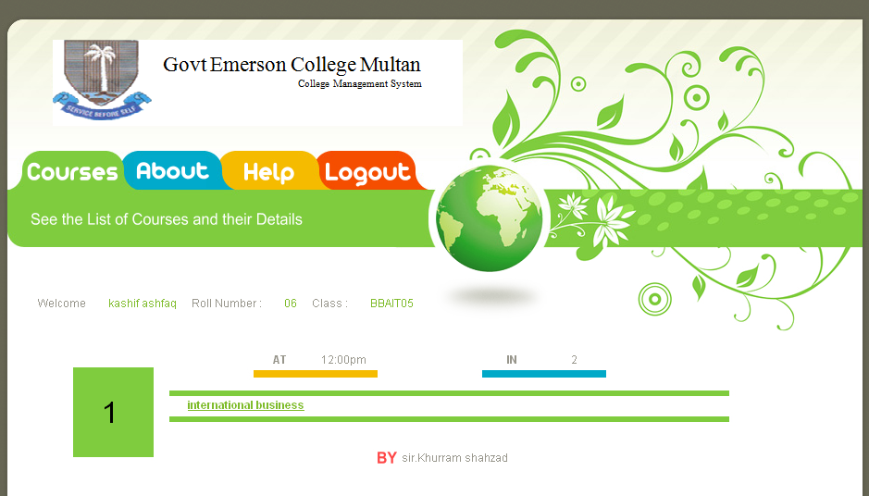

4) Teacher main page:-

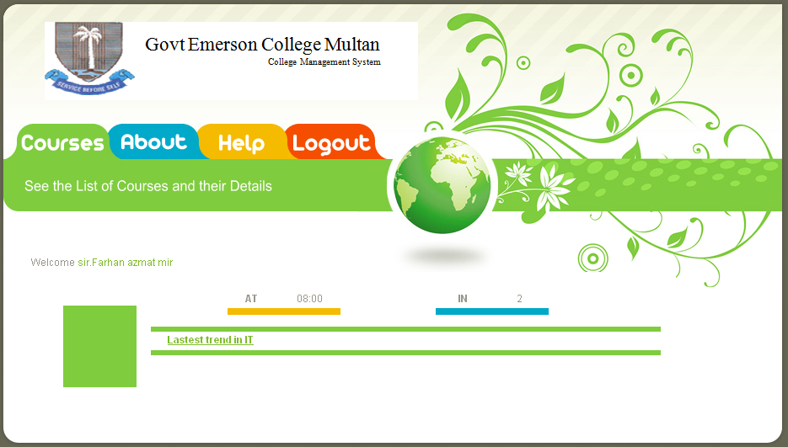

Implementation:-
- This system implementation not only paved the way of information seekers and information providers but also helps administrator to manage different administrative activities such as add user, add courses, add classes and can also generate reports.

- This system can be implemented on big, demanding and rush full institutions where there is a lot of rush of people and it is difficult to communicate everyone with satisfactory manner.

Recommendations:-
- It is recommended that this system should be implemented on the server which uses windows 2000 or windows XP. So that the WAMP server can be used.

- Another recommendation is to access this system on Internet explorer 7 or higher, Opera, Fire fox.

